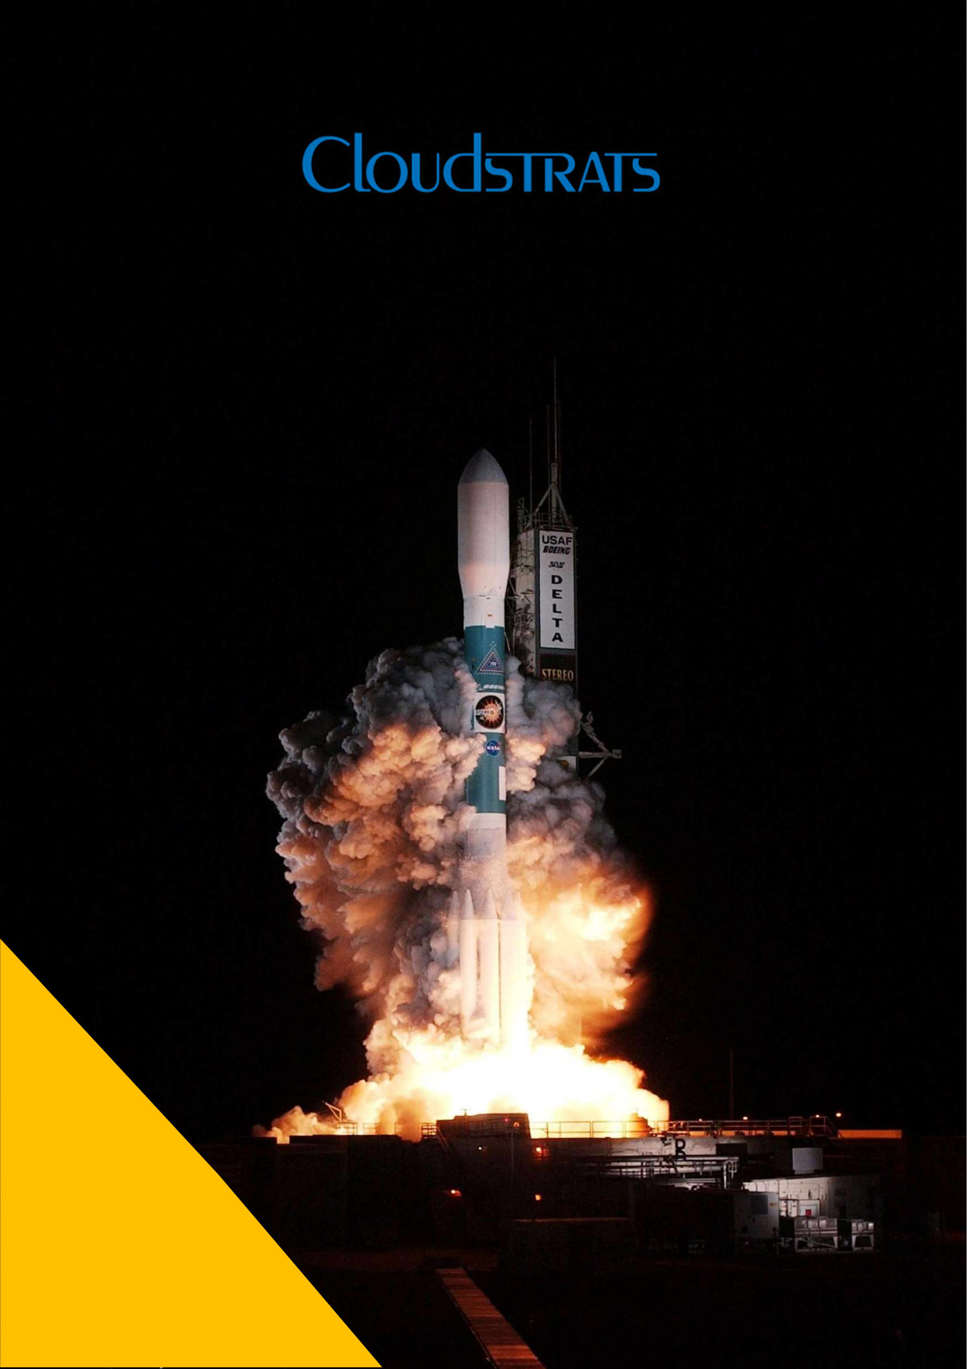

**Accelerate your Digital transformation**

1

Digital Transformation - A ground up approach

Over the past decade, there has been a wave of digital disruption with new, born-digital challengers compelling traditional incumbents to find and   
harness new ways of delivering great customer   
experiences in order to survive the new competition. While superior customer experience is an important marker of successful digital transformation for any enterprise, this approach can only be sustained if the organization’s underlying infrastructure is equipped to handle the demands of these customer-centric initiatives.

We help our customers to energize their core in a systematic fashion by:

**>**Identify the non-core aspects of the legacy   
 landscape and make them cloud-ready   
**>**Decouple the evolution of front-ends and back- ends with API-microservices, thus allowing for continuous renewal of the front, without   
 disrupting the core   
**>**Move from a product-centric landscape which is dominated by systems of record to a platform-led environment which support systems of innovation **>**Transform to a software-driven enterprise where the ERP core runs with cloud-efficiencies and is augmented with next-gen digital capabilities to drive better business outcomes

We worked closely with enterprises with large ERP and legacy landscapes, developing a digital   
transformation strategy and helping them simplify their core and run it with digital efficiencies - whether it’s spotting opportunities fast, re-engineering   
processes to respond more spontaneously, reducing cycle times, or delivering new experiences on   
demand, often by creating new business models.

**>**We are moving towards cloud-based intelligent systems that can “self-drive” businesses, helping enterprises develop a digital transformation   
 strategy to transform their systems of record to systems of intelligence   
**>**Our deep understanding of various business   
 verticals has enabled us to build robust industry reference models and transformation blueprints that can be customized to client contexts   
**>**We have a strong relationship with our business partners and understand their product roadmaps well enough to help recommend the right solutions to drive our clients’ transformation agenda

Cloudstrats is a Cloud Automation Company Offering   
Solutions, Advisory, & Managed Services Powered by   
Analytics & AI. We have helped over 150 customers in their digital transformation journey while maintaining industry standards and compliances.

Our Digital Transformation Capabilities includes:

**>**Comprehensive Cloud Migration to Azure, AWS, IBM Cloud & Google Cloud   
**>**Cloud Automation powered by Artificial Intelligence & Machine Learning   
**>**Application & Infrastructure Modernization   
**>**Hybrid Infrastructure Deployment   
**>**Process Re-engineering and Automation   
**>**DevSecOps Implementation   
**>**Cloud Native   
**>**Vmware & Citrix Hypervisor Deployments   
**>**Strategic deployment of Vmware Workspace One, Citrix Workspace & Amazon Workspaces   
**>**End-to-End Office 365 Migration   
**>**PowerApps & PowerBI Deployments

**On-premise to PaaS Platform**

One of the pioneers in providing micro loans to SMBs were running all their applications on an on-premise   
infrastructure and faced challenges in terms of resource utilization, scalability and security of the same. We helped them migrate to Azure to leverage its PaaS capabilities

**Solution Benefits:**   
- 60 % cost reduction on overall solution   
- Highly available & scalable infrastructure with load balancing capabilities

|  |  |
| --- | --- |
| - - | Infrastructure backed by Tier III Datacentres  All of their employees were trained on the solution |

**A Citrix VDI & Vmware vSphere Blend:**

A well-reputed organization from Healthcare domain had Business Critical applications running on on-premise   
infrastructure. Post detailed analysis of their applications & business requirements, we helped them deploy Citrix XenDesktop & XenApp on Vmware vSphere.

**Solution Benefits:**   
- Scalable Infrastructure with flexibility   
- Secured Platform with stringent data security policies - Significant cost reduction   
- 80 % average reduction in system issues

2



**Cloudstrats – Solutions | Advisory | Managed Services**

**About Cloudstrats:**

Cloudstrats is a global solutions and managed services company. We help our customers innovate their digital transformation journey with Automation, Analytics and AI. Our Advisory and Managed services leverage international exposure and expertise of our consultants who guide customers to manage optimization, confidentiality, and availability of their business and technology ecosystems.

Headquartered in New York, we serve global customers in India, Canada, Europe and the MENA region. Bootstrapped by first generation technopreneurs, we have been able to grow at a fast pace and have been honoured with multiple awards from the industry and our customers. We have helped over two hundred global customers adapt to their digital transformation leveraging Automation, Analytics and AI on Cloud. Cloudstrats values its customer’s business growth and practices innovative Balanced Scorecards and Net Promoter Scores to fuel our customers quest for best of breed technology adoptions. Our global Advisory and Managed services optimize our client’s investments.

**About Digital Transformation:**

Driven by our core value of ‘Customer Obsession’, our team of over 100 consultants improve Technology Strategy, Information Security, Business Continuity and Process Optimization with you. We provide Design, Build, Migration, Management, Modernization, Automation, Security and Optimization services to core areas of technology. This helps customers make the most effective strategic and tactical decisions related to their business at the pace that the digital world demands to Accelerate Transformation for the future. Cloudstrats creates value through synthesis of technology understanding, solution toolkits, deep industry and domain expertise, state of the art and next-generation technologies for automation, enhanced technology enablement, and actionable insight. Our technical prowess and ability to integrate state of the art technologies using VMware, Citrix, Microsoft, OpenStack along with the Big Four Public Clouds – Azure, AWS, IBM and Google enables us to provide Cloud Native services and build consolidation, capacity on demand with burstable compute and other resources on the cloud helps our customer embark on their Digital Transformation in an assured way.

© 2019 Cloudstrats Inc.   
All Rights Reserved.

This material has been prepared for general informational purposes only and is not intended to be relied upon as accounting, tax, or other professional advice. Please refer to your advisors for specific advice.

3